**Directions:** Use the following reading guide to take the virtual tour of the history of various events and technology from WWI. **All Questions** **Must be written in complete** **sentences and in your own words to receive credit**. **Double Grade**

**Part I:** **Trench Warfare: Can You Survive ??????**

**READ** Life in the trenches can be harsh as we have already learned in class. See if you have the decision making skills as a commander to survive when under fire and bring your troops home. 1st You are a soldier, make the correct decisions you’ll come home a hero. Make the wrong choices you’ll come home in a box. 2nd Do you have what it takes to lead men to victory as a WW1 Commander? Find out as your decisions will either bring victory or defeat to your country.

* [Over the Top](http://www.warmuseum.ca/overthetop/) Interactive Soldier Experience

* [Would You Have Made a Good Officer](http://www.schoolshistory.org.uk/westernfront/Western%20Front%20Sim.htm)?

1. Identify and Assess 3 Decisions which led to your and your men’s survival and success during Trench War.
2. Identify and Assess 3 Decision which led to your and your men’s death and destruction during Trench War.

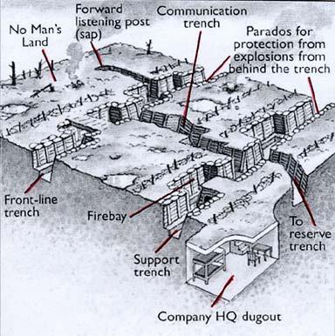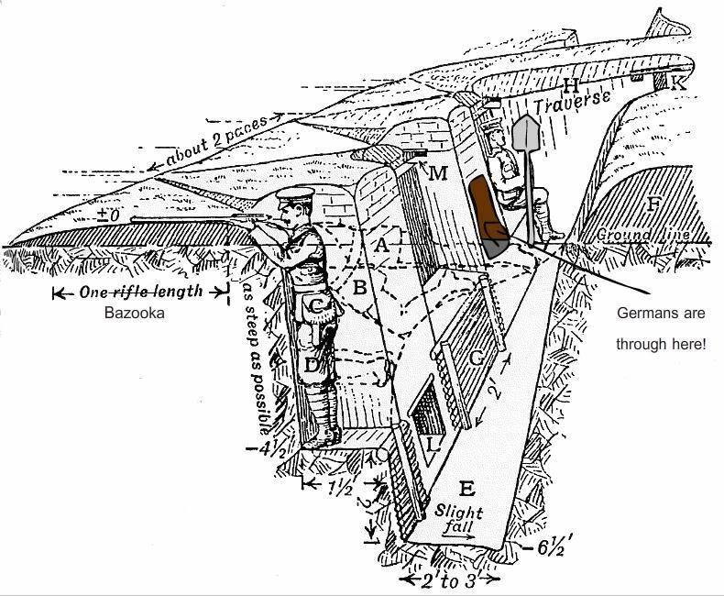

**Part I I:** **Key Events and Major Battles of WWI 1914-1918**

Early 1914: From the **Schlieffen Plan to Trench Warfare**

**Note: Read this first before the videos for B-H** [**Top 10 Battles**](https://www.iwm.org.uk/history/10-significant-battles-of-the-first-world-war)

1. In your own words explain how the German [Von Schlieffen Plan](https://www.historyonthenet.com/what-was-the-schlieffen-plan/) would potentially allow the Germans a quick victory in World War I.
2. On the Eastern front Germany would engage the Russians at the [**Battle of Tannenberg**](https://www.youtube.com/watch?v=y7qbZaf_olY) in September 1914. After watching the video explain what happened to the Russian Forces and in your own opinion what *‘Should’* have the Tsar of Russia decided to do after this monumental defeat.
3. In your own words explain how the French were able to win the [**Battle of Marne**](https://www.youtube.com/watch?v=WFvEnjtaCOA) on Sept. 10, 1914 causing German Field Marshall **Von Moltke** to famously say to the Kaiser ***“Sir, We Have Lost the War!”*** (Make sure to watch the clip).
4. Due to the Stalemate on the Western Front the British devised a plan to convince Germany they were on their own. Explain what happened during the disastrous [**Gallipoli Campaign**](https://www.youtube.com/watch?v=Qy5fHVfE3MQ) of 1915.
5. The German siege of the French Forts at [**Verdun**](https://www.youtube.com/watch?v=t7qS_) in 1916 was considered the

***Longest & Bloodiest Battle of WWI*.** By August the battle was considered to be a stalemate for both sides. According to the data how many people died and/or wounded throughout the 6 Month Siege on both sides of the conflict? In addition explain how Verdun is an example of a ***‘War of Attrition’***

1. Due to the Stalemate at **Verdun** the Allies decided it was time to break through the German defenses once and for all. Unfortunately British **General Douglas Haig’**s plan for the **[Battle of the Somme](https://www.youtube.com/watch?v=FvYIIuxh2kY)** in was a disaster leading to over (Not a typo) _______________ total casualties in 1 hours. By the end of 1916 both the Allies and Central powers looked for ways to end the war quickly due to the psychological side effects.
2. During 1915 the **2nd Battle of Ypres** was the ONLY attack the **Germans** carried out on the Western Front. During that battle the **Germans** revolutionized warfare by introducing **Mustard Gas**. Two years later the Allies believed that the territory around Ypres was necessary to win the war. Describe what happened during the [3rd Battle of Ypres](https://www.youtube.com/watch?v=39ZkQJtCv0w).
3. During the Spring and Fall of 1917 would change the European Continent for Ever. After watching the clips determine 3 Reasons why the [US. Would enter the War](https://www.youtube.com/watch?v=DHn1Egt6Xdg) on April 6, 1917 and what happens to Russia in November 1917.

1.

2.

3.

Russia???

1. How did the [Battle of Cambria](https://www.youtube.com/watch?v=vdj7YzY5vsI) on November 20, 1917 change the history of Warfare forever? Explain!
2. During the month of August 1918 the German would face what they called the ‘Black Day in German History’. Explain why August 8, 1918 the [Battle of Aimens](https://www.youtube.com/watch?v=niWf6C-aKFw) is considered the worst day for Germany in WWI.
3. The Last Allied Offensive occurred late in September 1918. (Remember to Add notes from Class Hint, Hint!!!)
4. By the Fall of 1918 the Allied Tactics wore down the Germans. Watch the [Clip](https://www.youtube.com/watch?v=wCBydHpDo40) and read [Facts 1-3](http://www.tenfactsabout.co.uk/0002armistice.htm) identify the Time, Date, Location, and Month the WWI Armistice went into effect.

